Test Case: tc002_SPX_Dev5_Crear_Requisicion_Spot_Tipo_Cobro_Project
Step 1 - Enter username and password and click to button Enter: Credentials Entered
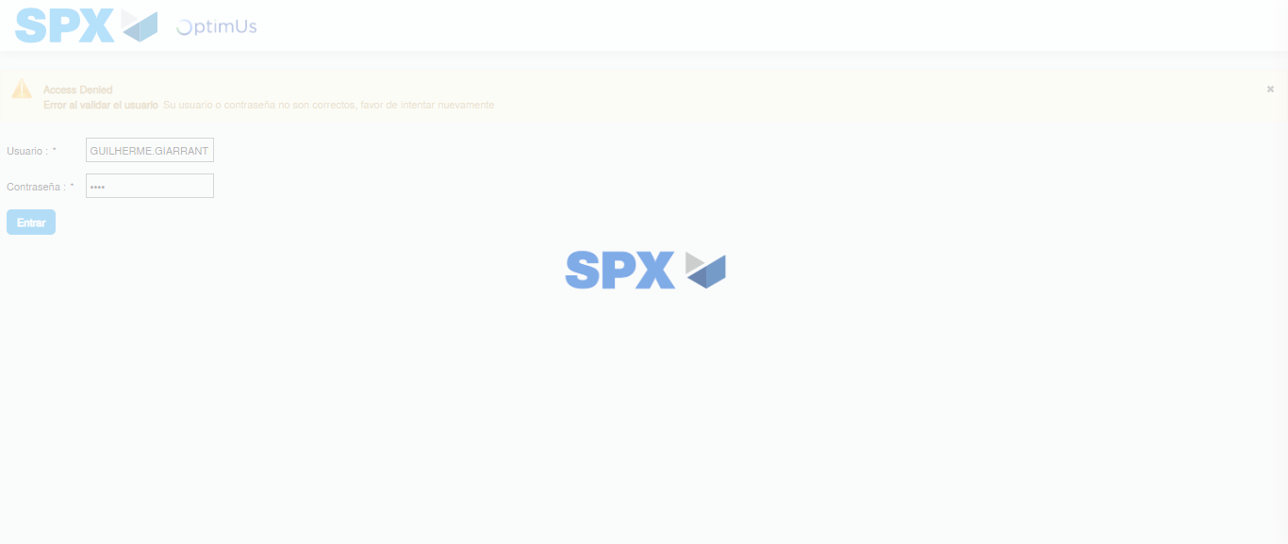Image file-name: QC_Testing-tc002_SPX_Dev5_Crear_Requisicion_Spot_Tipo_Cobro_Project-1784309046206

Step 2 - Select to UEN and Access to Spot Buy Requisitions : UEN Correctly selected and Correct access
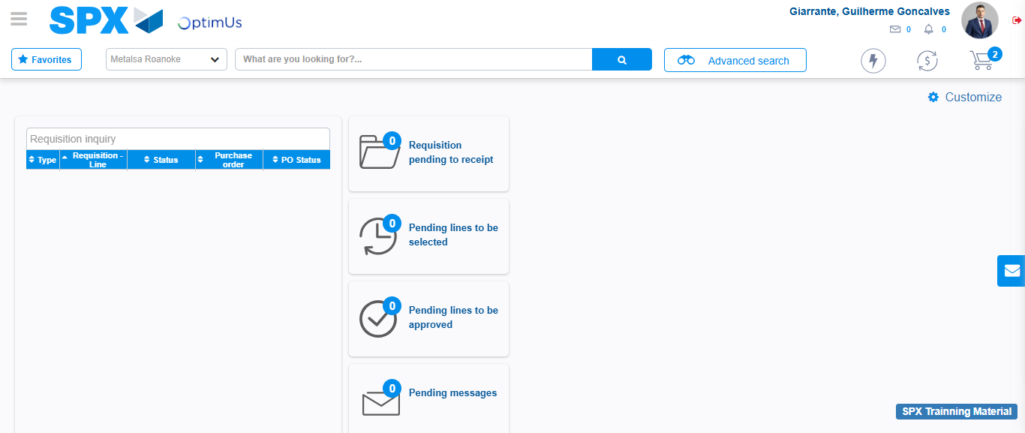Image file-name: QC_Testing-tc002_SPX_Dev5_Crear_Requisicion_Spot_Tipo_Cobro_Project-1784309077542

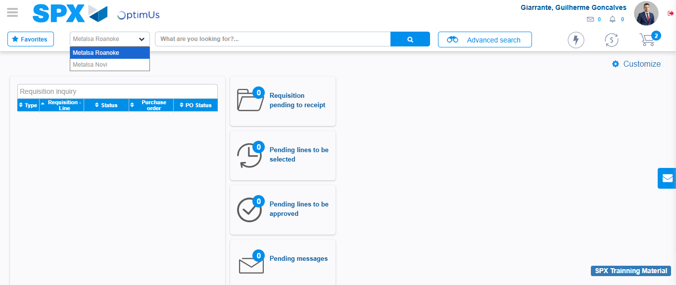Image file-name: QC_Testing-tc002_SPX_Dev5_Crear_Requisicion_Spot_Tipo_Cobro_Project-1784309080388

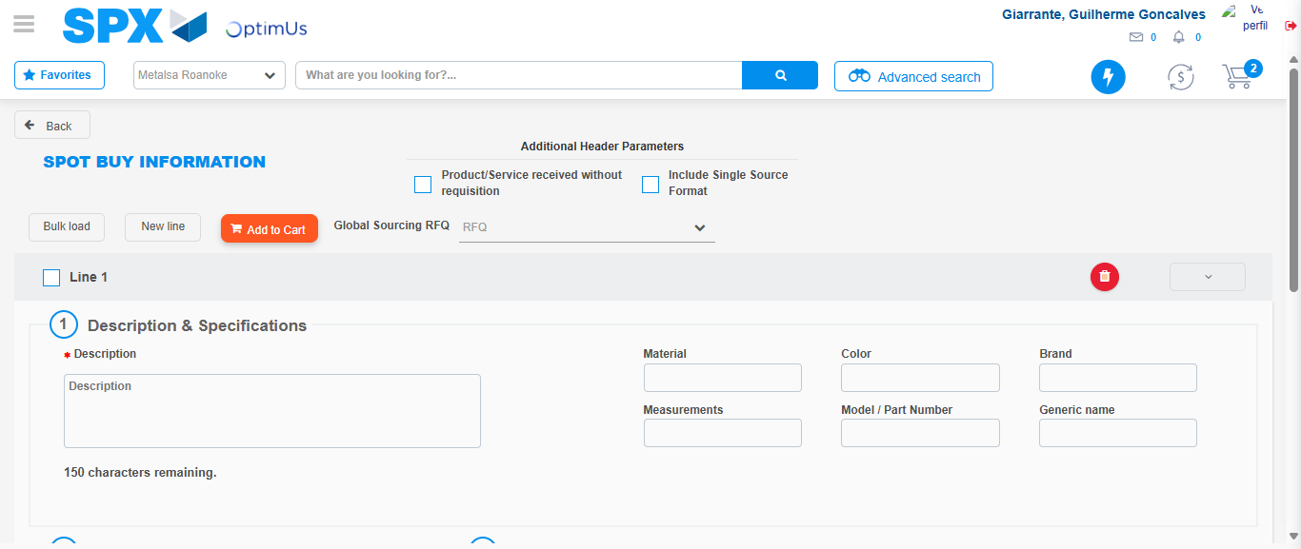Image file-name: QC_Testing-tc002_SPX_Dev5_Crear_Requisicion_Spot_Tipo_Cobro_Project-1784309100398

Step 3 - Data Capture Spot Buy Requisition: Data captured correctly
Image file-name: QC_Testing-tc002_SPX_Dev5_Crear_Requisicion_Spot_Tipo_Cobro_Project-1784309100638

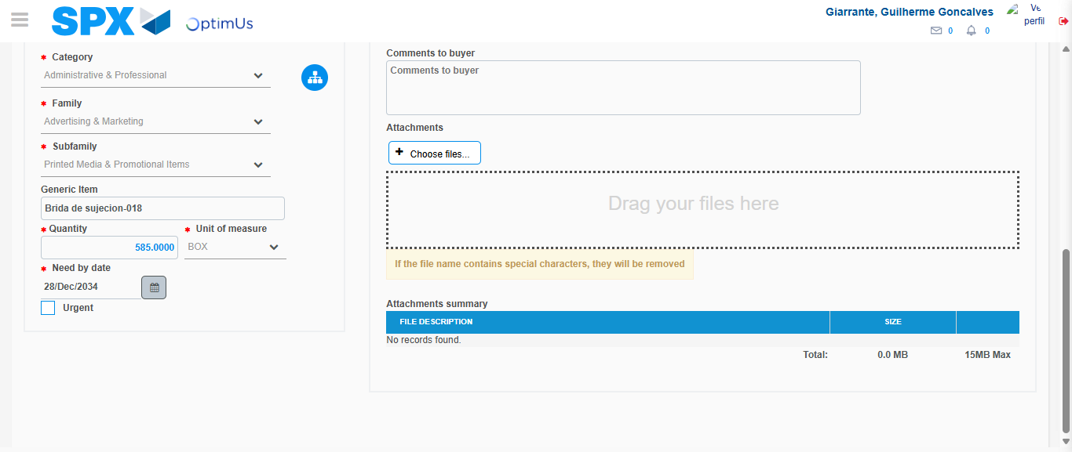Image file-name: QC_Testing-tc002_SPX_Dev5_Crear_Requisicion_Spot_Tipo_Cobro_Project-1784309116255

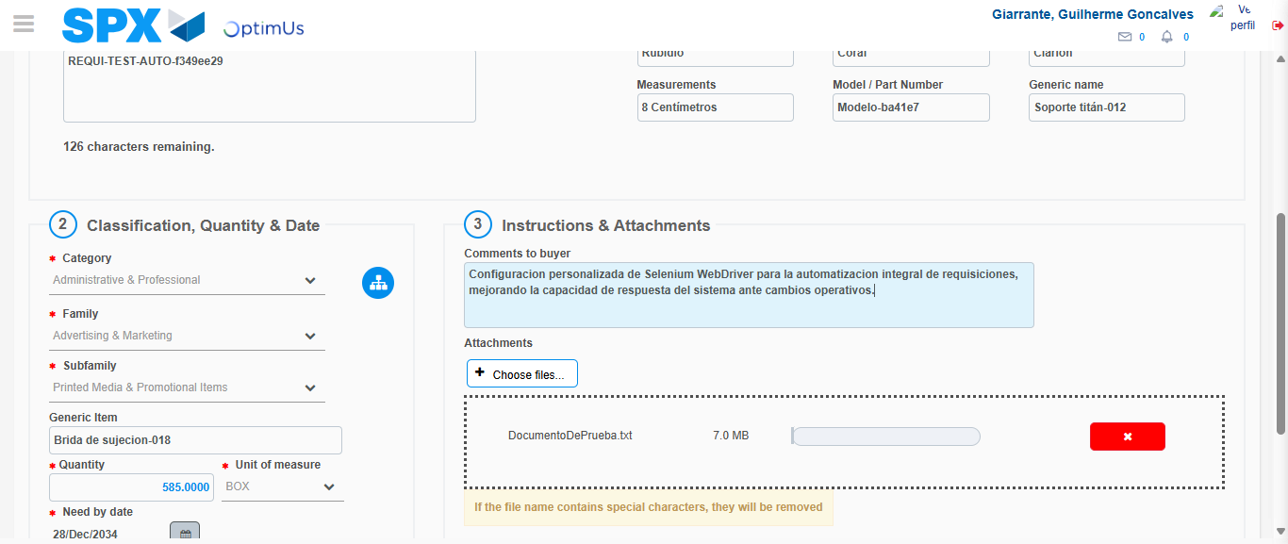Image file-name: QC_Testing-tc002_SPX_Dev5_Crear_Requisicion_Spot_Tipo_Cobro_Project-1784309117204

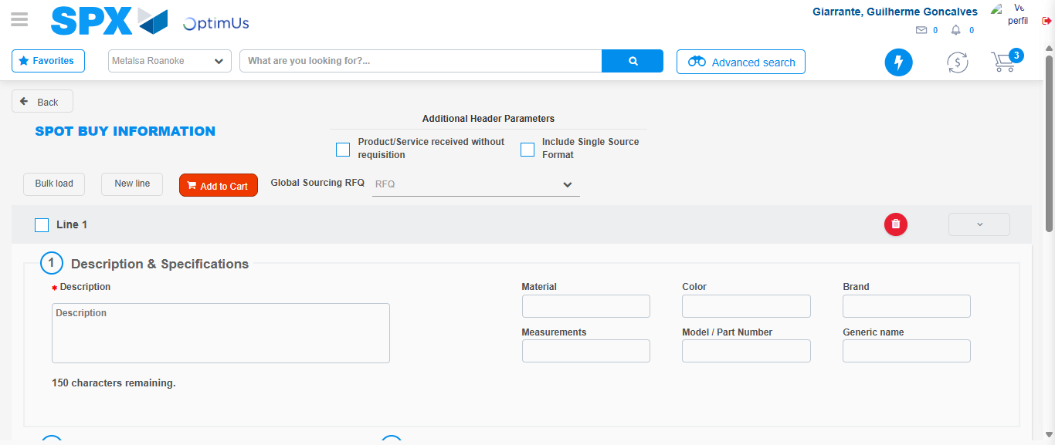Image file-name: QC_Testing-tc002_SPX_Dev5_Crear_Requisicion_Spot_Tipo_Cobro_Project-1784309133267

Step 7 - Return to Main Page SPX : Return to Main Page SPX
Image file-name: QC_Testing-tc002_SPX_Dev5_Crear_Requisicion_Spot_Tipo_Cobro_Project-1784309077542

Image file-name: QC_Testing-tc002_SPX_Dev5_Crear_Requisicion_Spot_Tipo_Cobro_Project-1784309080388

Image file-name: QC_Testing-tc002_SPX_Dev5_Crear_Requisicion_Spot_Tipo_Cobro_Project-1784309100398

Image file-name: QC_Testing-tc002_SPX_Dev5_Crear_Requisicion_Spot_Tipo_Cobro_Project-1784309135538

Image file-name: QC_Testing-tc002_SPX_Dev5_Crear_Requisicion_Spot_Tipo_Cobro_Project-1784309135733

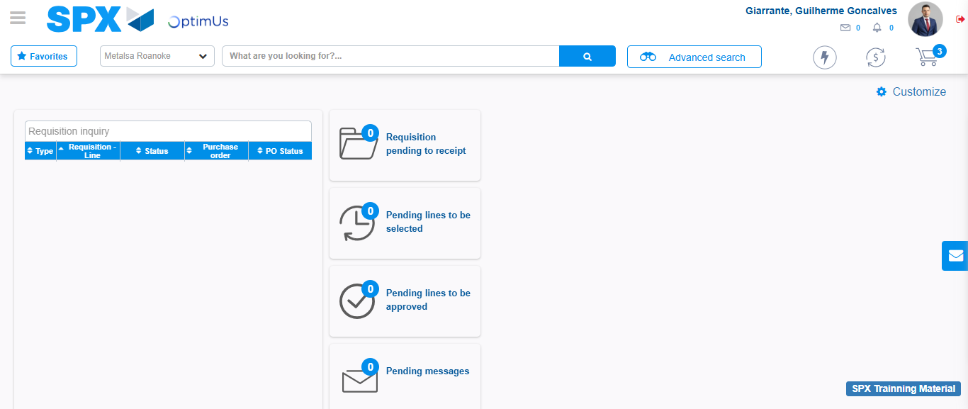Image file-name: QC_Testing-tc002_SPX_Dev5_Crear_Requisicion_Spot_Tipo_Cobro_Project-1784309157406

Step 8 - Log Out : Log Out SPX
Image file-name: QC_Testing-tc002_SPX_Dev5_Crear_Requisicion_Spot_Tipo_Cobro_Project-1784309157651

